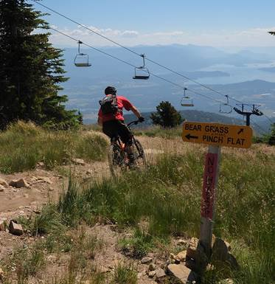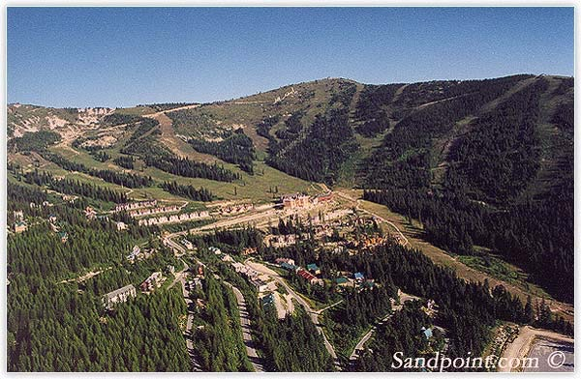

MOUNTAIN BIKING HIKING ROAD BIKING

Snojoke seller of travel: 601779662 trip insurance recommended

SOCIALS: Nightly BBQ’s. Trip payment includes meat & fixin’s, paper plates, etc. Everyone brings side dish & BYOB

This is a U-drive trip. Carpools will be arranged at a pre-trip party

SIGNUP: snojoke.org Trip Link-Summer Trips-Schweitzer

TRIP MAXIMUM: 15

Contact trip leaders with questions:

Kary York

[kary84@comcast.net](mailto:kary84@comcast.net)

425-417-2244

Jim Humenik

[blackdiamondpitch@yahoo.com](mailto:blackdiamondpitch@yahoo.com)

206-356-7033

MTN BIKE PARK: daily group rate pp= $21.46 includes tax (buy on site)

DOWNHILL MTN BIKE: below base area-4000 ft drop with shuttle service back to base. Each shuttle ride is $10; 2 rides per day (bring cash and buy on site)

MTN BIKE GUIDES: TBD (Locals may show us around)

CROSS COUNTRY TRAILS: free & available near the mountain

HIKING: plentiful in the area

ROAD BIKING: available in area

HOUSES: everyone pays equally regardless of bed type. Hot tubs & BBQ’s available

SCHWEITZER ALL SPORTS

ADVENTURE

July 6-9, 2017 $170 members\*

Payment due by June 1 \*$210 non-member